**LIBRARY MANAGEMENT SYSTEM**

**By: Ignatius Chan AA2303 (230653K)**

**FUNCTIONALITY:**

**Login and Account Management:**

* Users can log in with their usernames and passwords.
* New users can create accounts (with an admin key, “*admin123!*”) to access the system.
* All accounts are saved in a json file so that they can be re-used when the system is closed and opened again.

**Book Management:**

* Users can add new books to the library by providing details like ISBN, book name, type, and quantity.
* Existing book entries can be updated, allowing users to modify book names, ISBNs, types, and quantities.
* Users can view a tabulated list of books stored in the library, including options to sort and filter by book type.
* Books can be searched for using ISBN or book titles, and the search results are displayed.
* Users can delete books from the library.
* All books are saved in a json file so that they can be re-used when the system is closed and opened again.

**Settings and Keybindings:**

* Users can customize keybindings for various actions within the application.
* The application offers default keybindings for common actions.
* Keybindings can be reset to their default values (default keys are stored in a separate json file).
* All keybinds are saved in a json file so that they can be re-used when the system is closed and opened again.

**User Account Management:**

* Users can view their account details, including usernames and passwords.
* Users have the option to change their passwords and usernames.
* Accounts can be deleted, with confirmation prompts.

**HOW TO USE:**

**Things to install: tabulate (using pip install command)**

**Login:** Users log in with their registered username and password. New users can create accounts (with an admin key, “*admin123!*”).

**Main Menu:** After logging in, users are presented with a main menu where they can choose from various actions.

**Actions:**

* Add Book: Users can add new books to the library by providing details.
* Update Book: Existing books' details can be modified, including name, ISBN, type, and quantity.
* View Books: A list of library books can be displayed, sorted, and filtered.
* Search Book: Users can search for books by ISBN or title, with search results displayed.
* Delete Book: Books can be removed from the library.
* Log Out: Users can log out of their accounts.
* Settings: Users can access settings to view keybindings, customize keybindings, view their account details, change their passwords, change their usernames, and reset keybindings.

**FUNCTIONS AND WHAT THEY DO:**

**savebooks():** Saves the list of books to the "booklist.json" file.

**savesettings():** Saves the keybindings to the "keybinds.json" file.

**saveaccs():** Saves the list of registered accounts to the "accounts.json" file.

**isbnvalid():** Validates and returns a properly formatted ISBN.

**booktypevalid():** Validates and sets the book type (eBook, Hard Cover, or Paper Back).

**quantityvalid():** Validates and sets the book quantity.

**addbook():** Allows users to add a new book to the library by inputting details like ISBN, name, type, and quantity.

**isbninside(isbn):** Checks if a given ISBN is already present in the book list.

**nameinside(bookname):** Checks if a given book name is already present in the book list.

**viewbooks():** Displays the list of books, with options to sort and filter the list.

**filterbooks():** Displays a filtered list of books based on the selected book type.

**sortbooks():** Displays a sorted list of books based on the selected sorting criteria.

**totalbooks(booklst):** Calculates and displays the total number of books in a given list.

**displaybook(id):** Displays the details of a specific book based on the ISBN.

**updatebook():** Allows users to update the details of an existing book, including name, ISBN, type, and quantity.

**searchbook():** Allows users to search for a book by ISBN or title and displays the search results.

**deletebook():** Allows users to delete a book from the library.

**mainy():** Displays the main menu and allows users to perform various actions based on keybindings.

**loginpage()**: Handles user login, account creation, and admin key validation.

**createaccount():** Allows administrators to create new user accounts.

**loginval(username, password):** Validates user login credentials.

**editsettings():** Provides options to view and edit keybindings, view account details, delete accounts, change passwords, and reset keybindings.

**resetkeys():** Resets keybindings to their default values.

**updateuser():** Allows users to update their usernames.

**updatepass():** Allows users to update their passwords.

**editkeys():** Allows users to edit keybindings for various actions.

**conkey(key, act, index):** Confirms and updates keybindings with a new key.

**keyval(key):** Checks if a keybinding is already in use.

**resetpass():** Allows an administrator to reset the password for a user account using the admin key

**keyval(key):** Checks if a keybinding is already in use.

**resetpass():** Allows an administrator to reset the password for a user account using the admin key.

**wait():** Program waits for key press

**clearscreen():** Program clears screen for better visibility

**ADD NEW BOOK:**

* Application will check if isbn (with isbn validation) and book name already exists.
* Once all details have been filled with valid data, book is saved onto the booklist

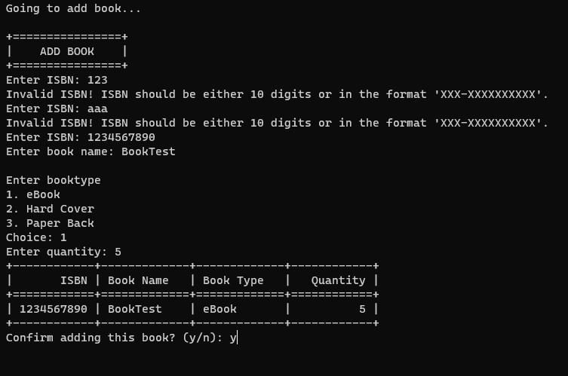

**UPDATE EXISTING BOOK:**

* User will be asked to key in the ISBN of the book they want to update.
* After user is satisfied, book details will be updated.
* User will be prompt if ISBN or book name already exists.

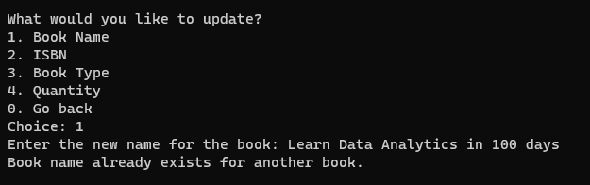

* + *Book name already exists…*
  + 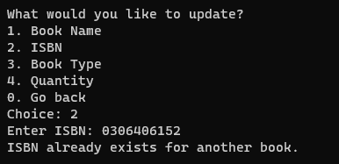
  + *ISBN already exists…*

**UPDATE EXISTING BOOK:**

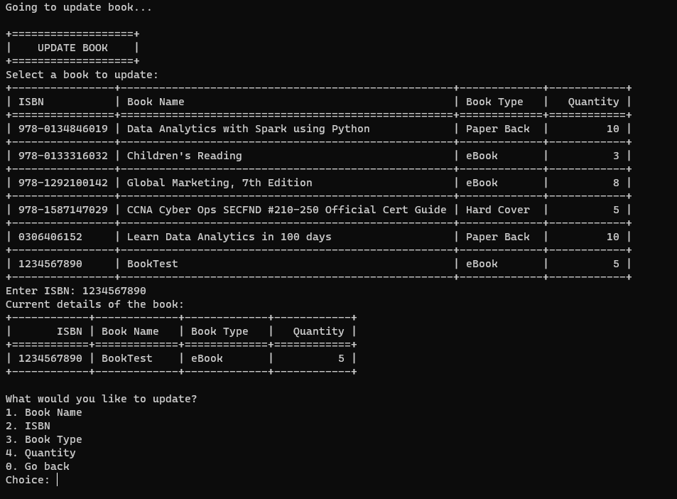

**REMOVE EXISTING BOOK:**

* User will search for book they want to delete by ISBN number.
* Confirmation prompt will ask user to confirm deletion.

**VIEW BOOK(S):**

* Tabulated list of books displayed.

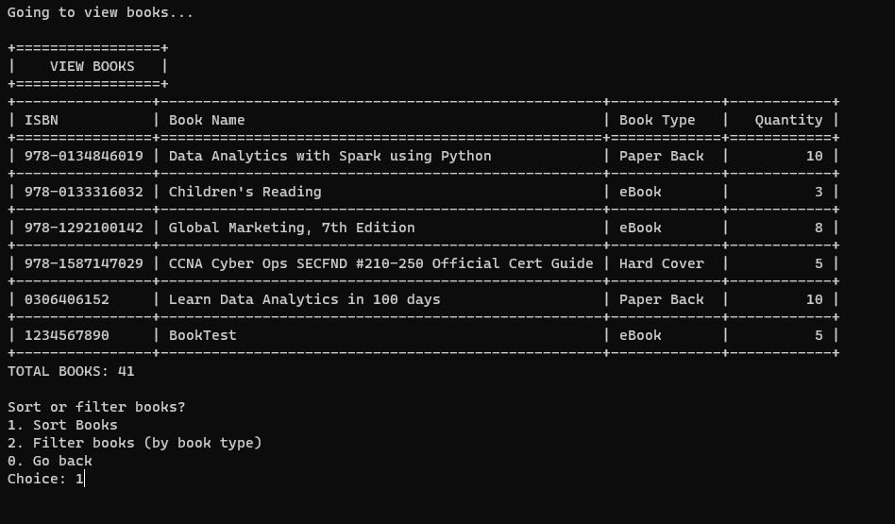

* *User will then be asked if they want to sort or filter the books…*
* Sorted by ISBN

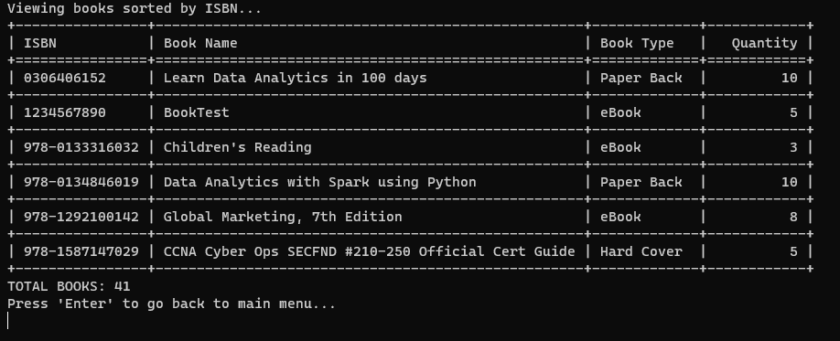

**VIEW BOOK(S):**

* Sorted by book name

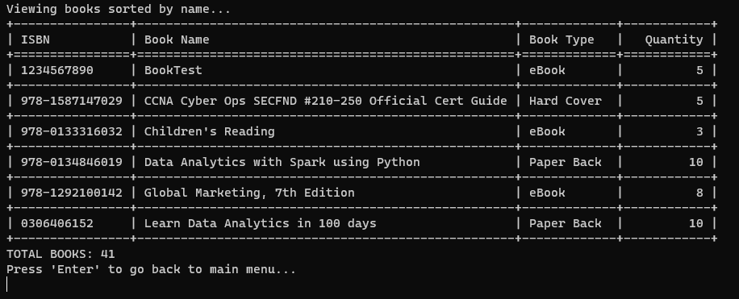

* Etc.

**VIEW BOOK(S):**

* Filtering books by book type

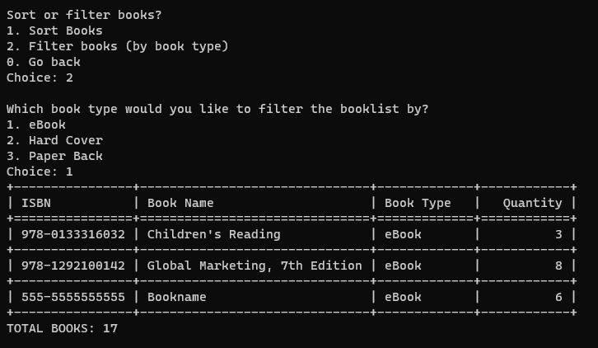

* Etc.

**ADDITIONAL FUNCTIONS / ADVANCED FEATURES:**

**TIME:**

* Python module ‘time’ was imported to not let the application be so static

**LOGIN AND/OR CREATE ACCOUNT:**

This feature was implemented as some of the information in an LMS may be private and should only be accessed by an authorised person.

* Users will be prompted if there are no accounts registered.
* Users will use admin key (“*admin123!*”) to create an account.
* Users are only allowed 5 attempts when logging in.
* Users can also switch between accounts using the log in and log out function without having to close the program.
* Users can reset their password if they forgot it by using the admin key.

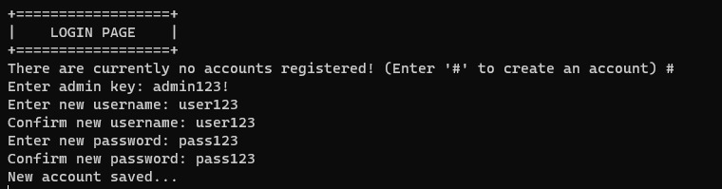

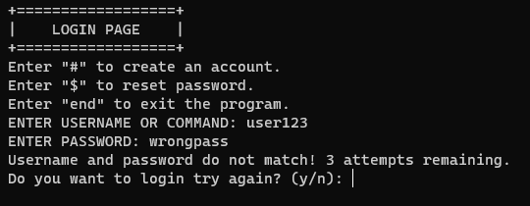

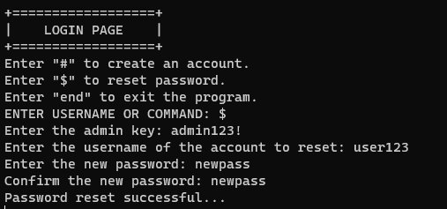

**ADDITIONAL FUNCTIONS / ADVANCED FEATURES:**

**SEARCH FOR A SPECIFIC BOOK:**

* Users can search for a specific book using ISBN or book name

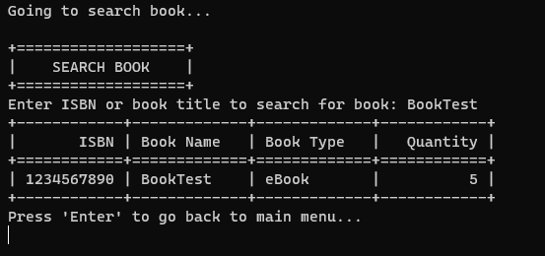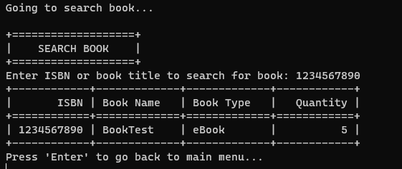

**ADDITIONAL FUNCTIONS / ADVANCED FEATURES:**

**SETTINGS:**

* Users can view the current keybind settings

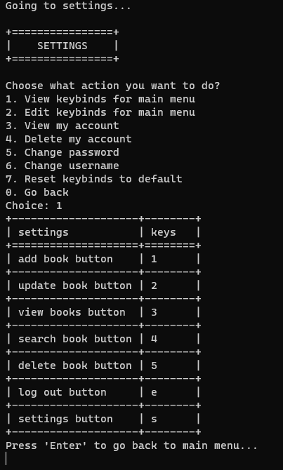

**ADDITIONAL FUNCTIONS / ADVANCED FEATURES:**

**SETTINGS:**

* Users can customize keybindings for various actions within the application.

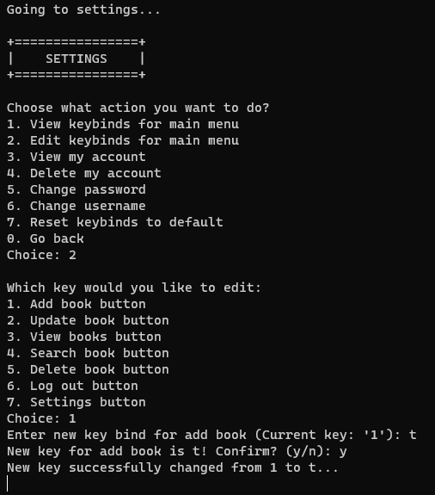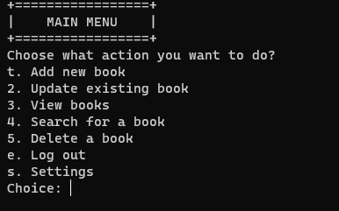

**ADDITIONAL FUNCTIONS / ADVANCED FEATURES:**

**SETTINGS:**

* Users can view their own account’s details.

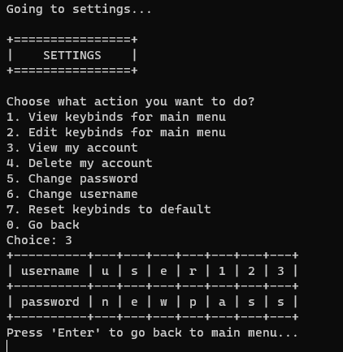

* Users can delete their account and the program will automatically log them out.

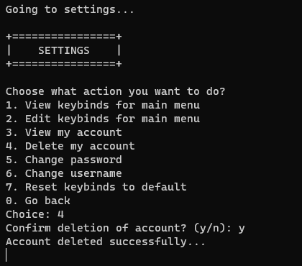

**ADDITIONAL FUNCTIONS / ADVANCED FEATURES:**

**SETTINGS:**

* Users can change their password.

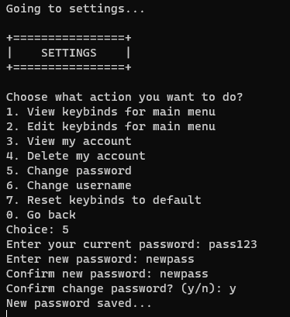

* Users can change their username.

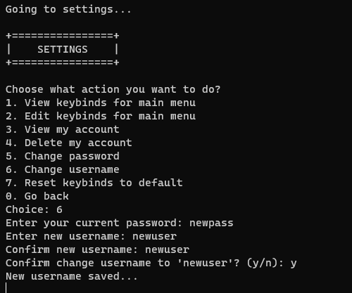

**ADDITIONAL FUNCTIONS / ADVANCED FEATURES:**

**SETTINGS:**

* Reset keybinds to default

